APPLICATION FOR MEMBERSHIP
Business name | Click or tap here to enter text.
Business address* | Click or tap here to enter text. |  |  |  | *Do NOT include address in business directory listing | ☐
Postal address  (if different from above) | Click or tap here to enter text.
Telephone | Click or tap here to enter text. |  | Mobile | Click or tap here to enter text.
Email | Click or tap here to enter text. |  | Website | Click or tap here to enter text.
Facebook/Social | Click or tap here to enter text. |  | Click or tap here to enter text.
Number of equivalent full-time employees (incl. owners) |  | # | ABN | ###

Business category (select the most relevant option)
Accommodation | ☐ | Cafés, Restaurants & Catering Services | ☐ | Household & Domestic Services | ☐
Advertising, Marketing, Design & Promotions | ☐ | Care & Support Services | ☐ | Medical & Health | ☐
Agriculture, Animals & Livestock | ☐ | Computing & Technology | ☐ | Other Services | ☐
Arts, Culture & Tourism | ☐ | Education, Training & Employment | ☐ | Retail & Shopping | ☐
Automotive | ☐ | Food & Groceries | ☐ | Sports & Recreation | ☐
Building & Construction | ☐ | Government | ☐ | Travel, Transport & Storage | ☐
Business, Financial & Consultancy Services | ☐ | Hair & Beauty | ☐ | Trades | ☐

Applicant (Business Representative)
To the committee,
I/We desire to become a Member of the Narrogin Chamber of Commerce Inc (NCC).
In the event of my/our application for membership being approved, I/We agree to:
- Be bound by the Rules, By-Laws and Constitution of the NCC
- Pay the membership fee as set by the Committee of the NCC
Representative name: | Click or tap here to enter text. | Signature: | Click or tap here to enter text.

Proposer (Current NCC Member)
- I believe that the above candidate/s is/are in all respects eligible for membership.
Representative name: | Click or tap here to enter text. | Signature: | Click or tap here to enter text.
Member business: | Click or tap here to enter text.

Please complete and return this form to Narrogin Chamber of Commerce at your earliest convenience.
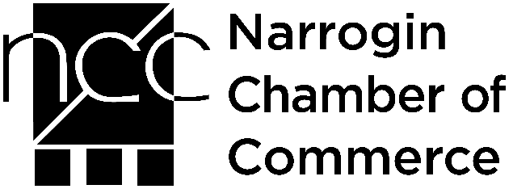 | PO Box 374, NARROGIN WA 6312
 | Phone: | 0474 924 337
 | Email: | admin@narroginchamber.com.au
 | Website: | narroginchamber.com.au
 | Facebook: | facebook.com.au/narroginchamber

OFFICE USE ONLY
Database: |  | MYOB: |  | Email: |  | Newsletter: |  | Facebook: |  | Sticker: |  | Website:

