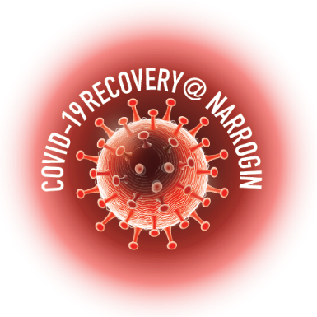
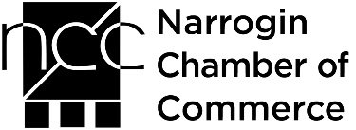
89 Earl Street, Narrogin
PO Box 1145, Narrogin WA 6312
T (08) 9890 0900
E enquiries@narrogin.wa.gov.au
W www.narrogin.wa.gov.au

PO Box 374 Narrogin WA 6312
Tel: 0474 924 337 |
admin@narroginchamber.com.au
www.narroginchamber.com.au

COVID-19 RECOVERY@ NARROGIN

APPLICATION FOR MEMBERSHIP

To the NCC Committee,

I/we desire to become a Member of the Narrogin Chamber of Commerce Inc (NCC). In the event of my/our application for membership being approved I/we agree to:

be bound by the rules, by-laws and constitution of the NCC; and

pay the membership fee as set by the Committee of the NCC.

Please ensure your current contact details are recorded below. All fields are required and some of these details will be loaded into the Members’ Directory on the Chamber’s website.

Business Name
Business Category
(check here)
ABN
Telephone
Mobile
Email
Website
Social Media sites:
Business Address:
Postal Address:
Number of Full Time Employees - (including owners)
Business Representative
(Contact Name)

I believe that the above candidate/s is/are in all respects eligible for membership.
*Proposed by NCC Member Business Name:…………………………………………………………………………………………………………..
Print Name: ……………………………………………………….. Signature …………………………………… ………./…../…..
* must be a current NCC Member

OFFICE USE: | Database |  | Email |  | Facebook
 | MYOB |  | Newsletter |  | Sticker
 | Website

